Tuan Nguyen

Lab4 : File System

**Program Description**

-The project is to create a file system to store file and directory in a drive of 2MB. Each data is stored in block of size 512. The first 10 block will store the fat table and the next 2 block will store the directory table contain the directory entry to the table and root directory. The rest of block from 13 to 4096 will store data contain new file that the user created. There are build-in functions that allow the user to use file system. For example, create , delete, open, close , mkdir, and ls. When the program start, the user will be in root directory. Each time the user create a new directory or new file, the path of user will be reset to new path of the new directory or file that user created.

To run program:

if the user want to **create a file**, type: create <nameFile>, the first file is saved in data_region block(13)

-search for file in root directory, if already exist generate error.

-if not, create a file and allow user to write something inside the file.

if the user want to **open a file**, type: open <nameFile>

-It will print the content of the file

-if the user type invalid <namefile> or name of file that haven’t created to open, print error message.

if the user want to **close a file**, type: close <nameFile>

- It will go back to root directory, and print file is closed.

if the user want to **read a file**, type: read <nameFile>

-Display the content inside the file to screen

-if the user type invalid <namefile> or name of file that haven’t created to read, print error message.

if the user want to **write a file**, type: write <nameFile>

-The user can type a sentence to write to file, and saved.

if the user want to **create a directory**, type: mkdir <nameDirectory>

-Allow the user to type in name of directory to create

-if the user type invalid <nameDir> or name of directory that already created, print error message. Ask the user to type another directory name

if the user want to **see the content of file system**, type: ls

-print the list of file and directory name that the user created

if the user want to **exit file system**, type: exit

-the program will exit

if the user want to see **how data are stored in file system**, type: hexdump –C Drive2MB

-print a hexadecimal number corresponded to the location of data that stored inside a Dirve2MB.

To Compile

-cd lab4

-make

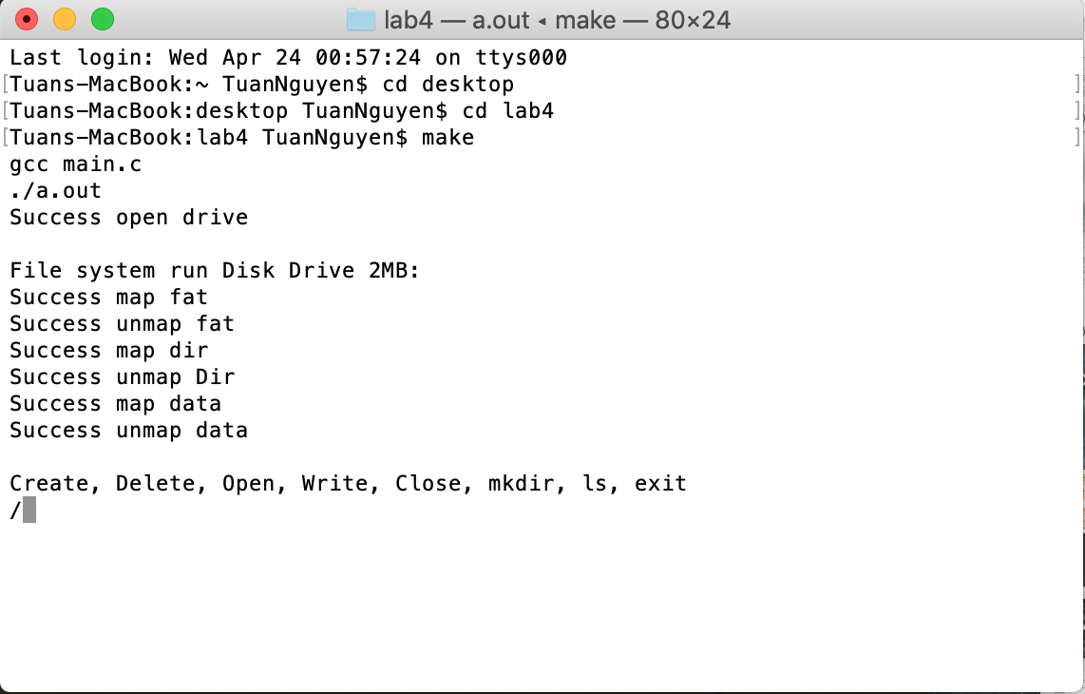

Testing

-Create a file: in.txt and write “hello”

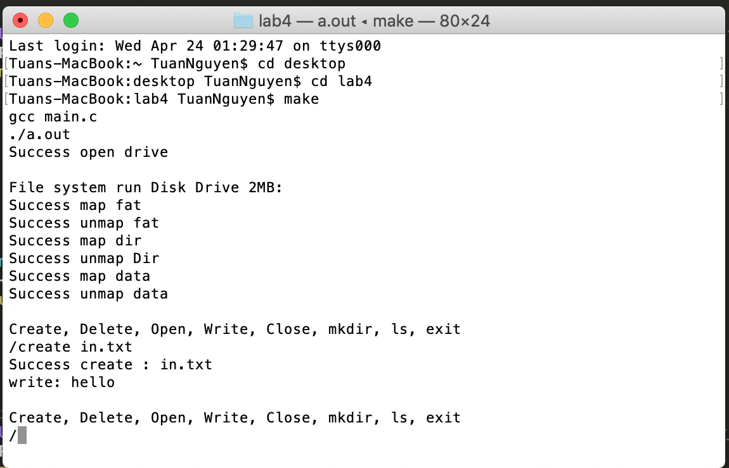

-Open a file : print the content to screen and the location store

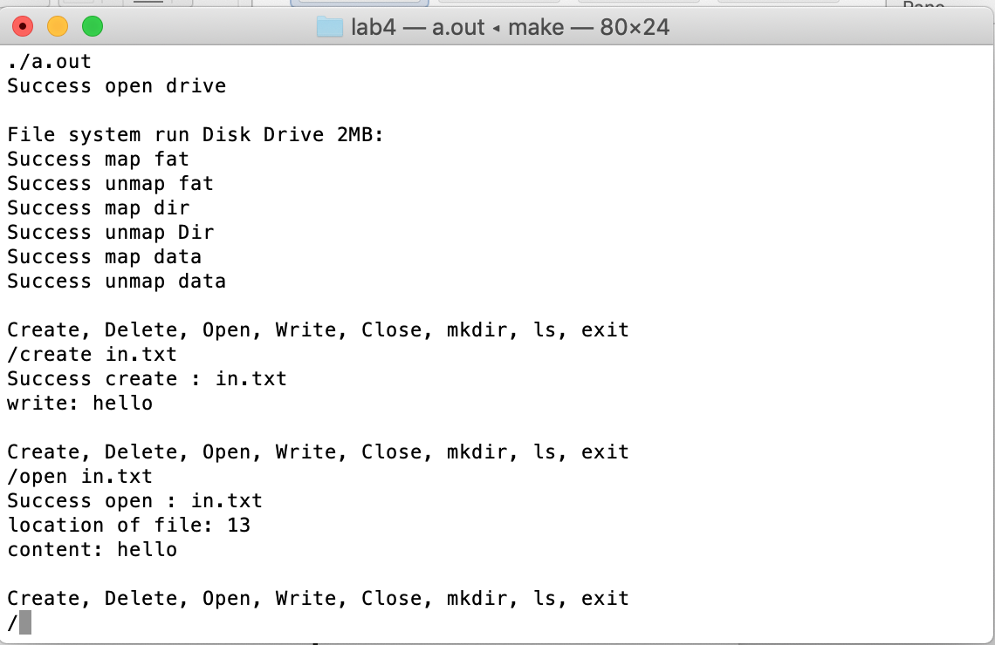

-Close a in.txt file: print file is close

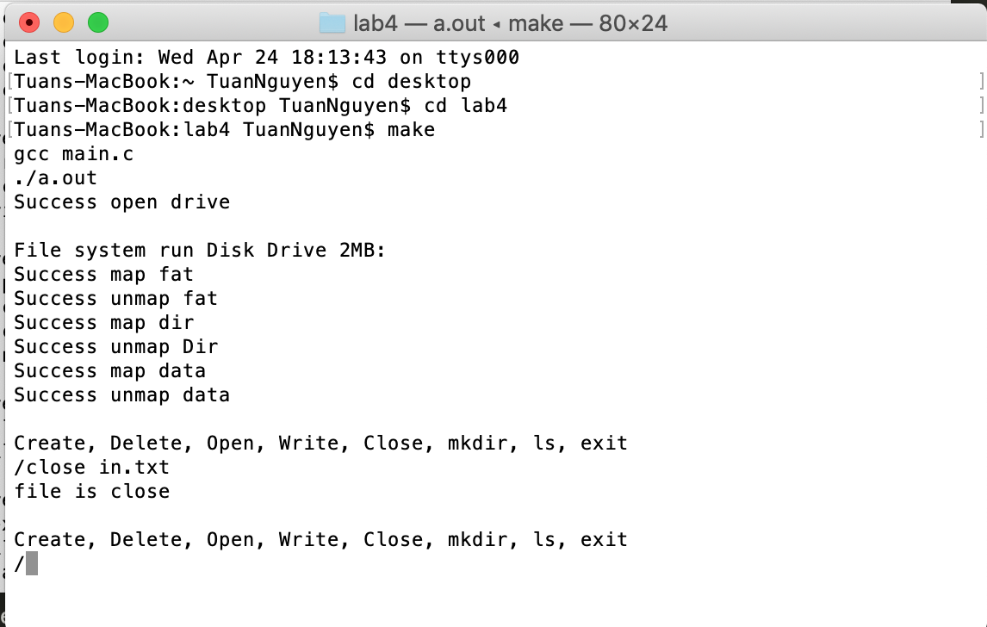

-Read a in.txt file: print content of file to screen

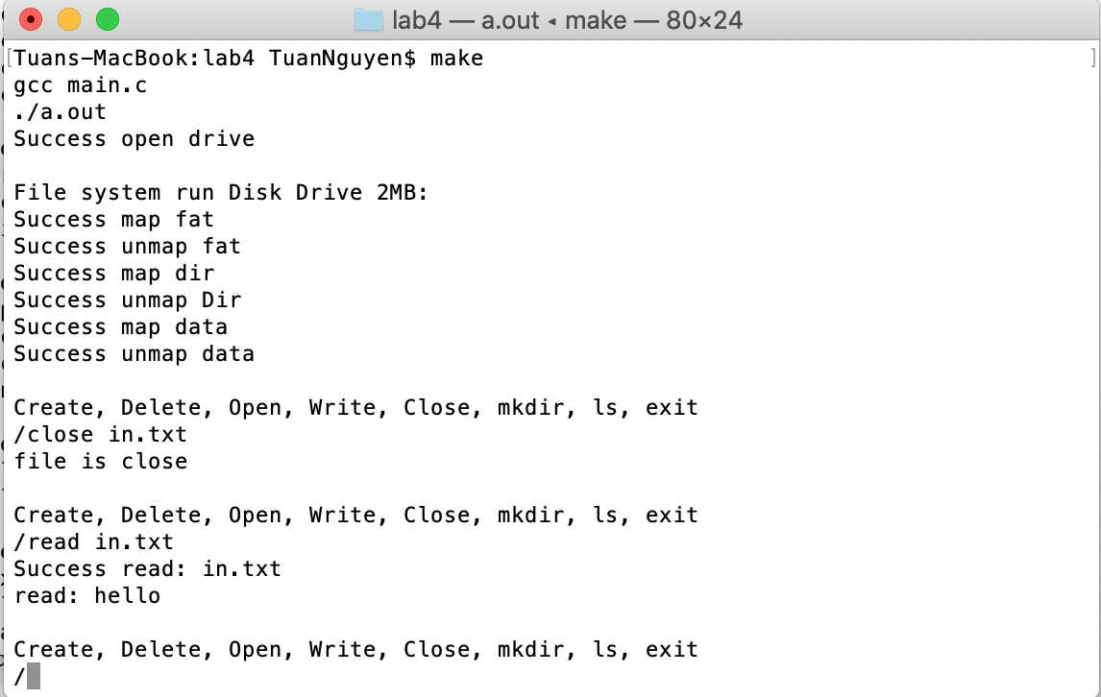

-Make a directory: my mkdir doesn’t work

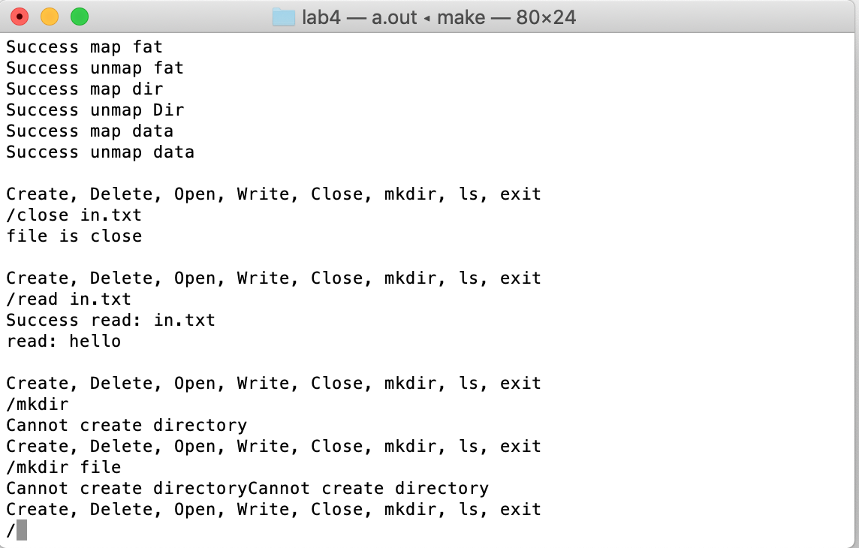

-ls: list the content of file system

